

**MUSTAFA KEMAL UNIVERSITY**

**7th ERASMUS+ STAFF WEEK**

**02 - 06 May 2016**

**GENERAL INFORMATION AND APPLICATION FORM**

**GENERAL INFORMATION**

**AIM OF THE EVENT**

Our main goal to organize the 6th Erasmus Staff Week is to create an opportunity for our partners to introduce their universities, to learn about Turkey and Turkish culture, and to share experiences with others while carrying out Erasmus Teaching or Training activity in the frame of Erasmus+ Staff Exchange program. A five-day program was planned with this aim.

Any academic or administrative staff working at our partner universities or other European universities willing to make new collaboration can apply for the 6th Erasmus Staff Week which will take place in Antakya, Hatay, Turkey in **02-06 May 2016**.

**APPLICATION**

Those willing to join the event should download the application form from the International Office’s web site (<http://int.mku.edu.tr>, Erasmus menu) and then fill in the Application Form and send it to [erasmus@mku.edu.tr](mailto:erasmus@mku.edu.tr) and [mkuerasmus@gmail.com](mailto:mkuerasmus@gmail.com) by e-mail. It is not necessary to send the Application form by regular mail.

The status of the application will be determined within about one week after the application form is received. A letter of invitation will be sent to the staff whose application is accepted.

**COSTS**

There is no participation fee for the program. Participants should cover their travel and accommodation costs. Costs for the excursion, transportation, lunches, and dinners mentioned in the program will be covered by the Mustafa Kemal University International and Erasmus Office.

Participants may contact their university’s Erasmus Office to obtain Erasmus+ program staff mobility grants to cover the costs.

**LANGUAGE**

The language of the event is English. We require sufficient knowledge of English from all participants.

**ABOUT ANTAKYA AND HATAY**

Hatay is one of the 81 provinces of Turkey. It is located in the mid-south of Turkey. Antakya is the central city of the Hatay province. The main campus is located in 15 km north of the Antakya city center and about 10 km south of the Hatay international airport (please see the map below). Antakya is famous for cultural and historic assets (mainly mosaic artifacts), St.Peter’s grotto church, Turkish and middle eastern cuisine, and beaches.

**TRANSPORTATION**

Hatay has an international airport which is about 25 km north of the Antakya city center and 10 km north of the Mustafa Kemal University Main Campus. The Main campus named “Tayfur Sökmen Campus” is between Antakya city center and the airport (please see the map below). **We will arrange a pickup from the airport for all guests**.

Flights are available from both Istanbul and Ankara (capital city) to Hatay International Airport. You should buy your flight ticket to Hatay International Airport.

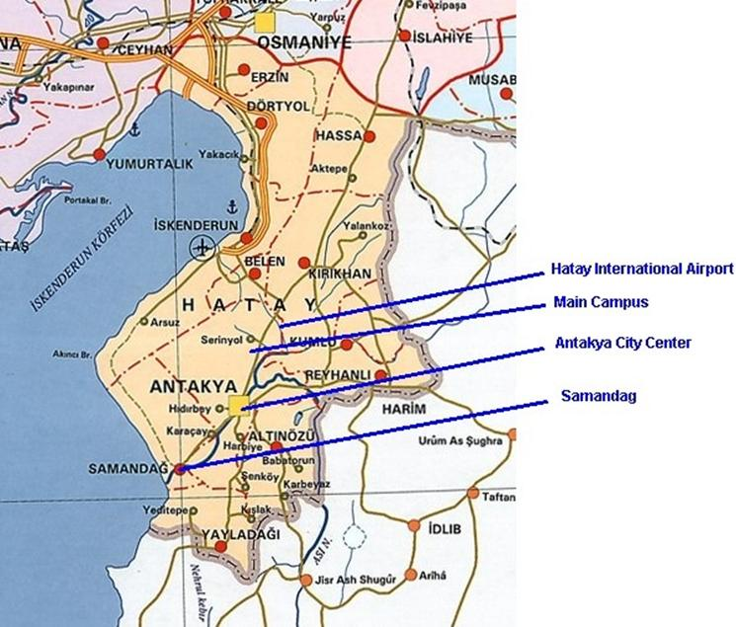

**CLIMATE AND WEATHER CONDITIONS**

It is generally hot in May in Antakya. The average temperature is about 25-30ºC at daytime and 20-22ºC at night.

**CURRENCY**

The currency in Turkey is Turkish Lira (TL). Other currencies including Euro and USD can be exchanged in currency exchange shops or in banks located in the city center. Most shops usually accept payments in Euro and USD. As of January 2016, 1 Euro is about 3.20 TL and 1 USD is about 2.90 TL.

**ACCOMMODATION**

The guests can choose one of the places below.

1) MKU Guest House (**/***) (will be booked by the MKU Erasmus Office)

Our university has a guest house in Antakya city center located on the main street (Ataturk Street). It has 25 rooms. All rooms have TV and bathroom inside. The guest house also has a small restaurant in the first floor. Breakfast, lunch, and dinner are served in the guest house.

As of January 2015, the price is about 55-60 TL (about 20 Euros) for a single room and 75-80 TL (about 25 Euros) for a double room per night (including breakfast and taxes). (1 Euro = 3.20 TL)

Address: Mustafa Kemal Üniversitesi Rektörlük Misafirhanesi, Atatürk Caddesi, 31040 Antakya, Hatay

(Mustafa Kemal University Rectorate, Guest House, Ataturk Street, 31040 Antakya, Hatay)

2) Narin Hotel (****) (has to be booked by the participant)

Narin Hotel is on the main street (Ataturk Street) in the city center close to many restaurants and a big shopping mall (Palladium shopping mall).

The price for Single Room is about 50-55 Euros.

The price for Double Room is about 70-75 Euros.

Address: Atatürk St. No:11 Antakya, Hatay

Phone: 0090 326 216 7500

Web: [www.narinhotel.com](http://www.narinhotel.com)

E-mail: [info@narinhotel.com](mailto:info@narinhotel.com)

**CONTACT INFO:**

**Address:** Mustafa Kemal University Rectorate

International Relations & Erasmus Office

Tayfur Sokmen Campus

31040 Antakya, Hatay, Turkey

**Phone:** +90 326 221 5815 (Within Turkey: 0 326 221 5815)

**Fax:** +90 326 221 5815 (Within Turkey: 0 326 221 5815)

**E-mail:** [erasmus@mku.edu.tr](mailto:erasmus@mku.edu.tr), [mkuerasmus@gmail.com](mailto:mkuerasmus@gmail.com)

**Internet:** MKU Faculties and Departments Course catalogue: <http://bbs.mku.edu.tr>

MKU International Office: <http://int.mku.edu.tr>

MKU main web page: <http://www.mku.edu.tr>