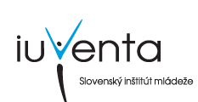
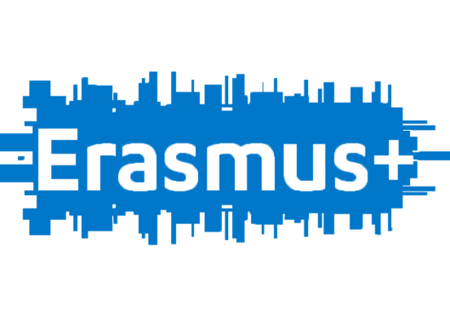
Think Globally, Do Business Locally: Development of Rural Areas through Enterprise 29.4.-7.5.2016; Raztocno, Slovak Republic

Personal information
Name, surname
Gender
Date of birth, age
Adress, country of residence
Your contact
Emergency contact (name, adress, call number)
Your Email
Level of English | poor – fair - good – fluent

Have you any special diet needs ? (vegeterian etc.) /
Have you any special medical needs ? /

What do you expect from this youth Exchange ? What is your motivation ?
Have you ever participated in other mobility projects ? If yes, please explain.

